**SRINIVAS UNIVERSITY**



**INSTITUTE OF ENGINEERING AND TECHNOLOGY**

MUKKA, SURATHKAL, MANGALORE-574146

**MAJOR PROJECT REPORT**

### ON

**“Project MatrixX - Digitalized Crypto-Token”**

***Submitted in the partial fulfillment of the requirements for the award of the degree of***

**BACHELOR OF TECHNOLOGY**

**IN**

**CLOUD TECHNOLOGY AND INFORMATION SECURITY**

**Submitted By,**

**Keerthan M.S 1SU19CI013**

**Ashin Rajeev 1SU19CI008**

Under the Guidance of

**Mr . Daniel Francis Selvaraj**

(HOD) of CTDS Department

2021-2022

**SRINIVAS UNIVERSITY**



**INSTITUTE OF ENGINEERING & TECHNOLOGY**

**Mukka , Mangalore-574146**

**CERTIFICATE**

This is to certify that the project entitled “ **Project MatrixX - Digitalized Crypto-Token** ” is a bonafide work carried out by ***Keerthan M.S , Ashin Rajeev*** bearing the ***1SU19CI013, 1SU19CI008,*** in the partial fulfillment of **Bachelor of Technology** in **Cloud Technology** of the **Srinivas University Institute of Engineering and Technology** during the year **2022-2023.** It is certified that all corrections/suggestions indicated for internal assessment have been in corporated in the report deposited in the department library. The internship report has been approved as it satisfies the academic requirements in respect of internship work prescribed for the said degree.

Name & Signature of the Guide Name & Signature of the H.O.D

**Mr. Daniel Francis Selvaraj Mr. Daniel Francis Selvaraj**

Signature of the Dean

**Dr. Thomas Pinto**

Dean, SUIET, Mukka

**External Viva**

Name of the Examiners Signature with date

1. ------------------------------------

**SRINIVAS UNIVERSITY**



**INSTITUTE OF ENGINEERING & TECHNOLOGY**

**Mukka , Mangalore-574146**

**DECLARATION**

We, **Keerthan M.S, Ashin Rajeev** the student of eighth semester, **B.Tech** in Data Science, Srinivas University, Mukka, hereby declare that the project entitled “**Project MatrixX - Digitalized Crypto-Token**” has been successfully completed by me in partial fulfillment of the requirements for the award of degree in **Bachelor of Technology in Cloud Technology of Srinivas University Institute of Engineering and Technology** and no part of it has been submitted for the award of degree or diploma in any university or institution previously.

**Date:** ____________

**Place:** Mukka

# ACKNOWLEDGEMENT

We would like to take this opportunity to express my profound gratitude to my respected project guide **Mr. Daniel Francis selvaraj in Cloud Technology** for his ever-inspiring guidance, constant encouragement and support.

We sincerely thank **Mr. Daniel Francis Selvaraj** , Head, of CTDS Department, for being an inspiration and support throughout this project.

We are extremely grateful to our respected Dean, **Dr. Thomas Pinto** for providing the facilities to carry out the project.

We also would like to thank our Management, **A. Shama Rao Foundation,** Mangaluru, for providing the means and support for the completion of the project.

We would like to thank **Mrs. Renisha, Professor in CTDS Department, Mr. Daniel Francis Selvaraj , Head of CTDS Department, Dr. A Sasi Kumar, Professor in Data Science, and non-teaching staff of CTDS Department** for their support and help.

Finally, We express our profound gratitude to our parents and friends who have helped us in every conceived manner with their valuable suggestions, encouragement and moral support.

Keerthan M.S

Ashin Rajeev

**TABLE OF CONTENTS**

**List of Figures**

**Abstract**

**1. Introduction**

1.1 The Domain

1.2 The Problem

1.3 The Technology

**2. System Analysis**

2.1 Existing Systems

2.2 Proposed System

2.3 Hardware and Software Specifications

**3. System Design**

3.1 Architecture of Blockchain

3.2 Working of Blockchain

3.3Step by Step Demonstration

**4. Conclusion**

**5. References**

**LIST OF FIGURES**

**FIGURES PAGE NO.**

1. Cryptocurrency 15
2. Proof of Work 22
3. Proof of Stake 25
4. Proof of history 28
5. Remix IDE 30
6. Meta-Mask 31
7. Pancake Swap Exchange 34
8. Code of Contract 38
9. Sepolia test token 39
10. Integration of MetaMask 40
11. Deployment of token 41
12. Gas Fee demonstration 42
13. Block contract confirmation 42
14. Verify and Publish 43
15. Import tokens 44
16. Liquidity 45

**ABSTRACT**

A cryptocurrency token, or simply a token, is a type of digital asset that is built and operates on top of an existing blockchain network, such as Ethereum, Binance Smart Chain, or Solana. Cryptocurrency tokens are typically created by developers and entrepreneurs to represent various assets, such as a unit of value, a piece of property, or a financial instrument.One of the key benefits of cryptocurrency tokens is that they enable developers and entrepreneurs to create and launch their own decentralized applications (dApps), services, and platforms on top of an existing blockchain network, without having to build their own blockchain from scratch. Tokens can be used to represent ownership in a decentralized autonomous organization (DAO), access to a service or platform, or even to represent physical assets in the real world, such as real estate or commodities.Overall, cryptocurrency tokens have enabled a new wave of innovation and experimentation in the blockchain industry, allowing developers and entrepreneurs to create new decentralized applications, services, and platforms, and offering investors new opportunities to invest in digital assets and participate in decentralized networks.

CHAPTER 1

INTRODUCTION

**CHAPTER 1**

**INTRODUCTION**

**1.1 Domain Introduction**

Blockchain is a decentralized, digital ledger technology that is used to record transactions across a network of computers. It was first introduced in 2008 with the creation of Bitcoin, a cryptocurrency that uses blockchain technology as its underlying platform. However, since then, many other applications of blockchain technology have emerged.

1. The fundamental concept behind blockchain is the creation of a distributed database where data is stored in blocks, and each block is linked to the previous one, forming a chain. This chain of blocks is stored across a network of computers, making it virtually impossible to alter any previous transactions without the consent of the network.
2. Each block in a blockchain contains a set of transactions that have been verified and validated by the network. The network participants, also known as nodes, use complex algorithms to reach a consensus on the validity of each transaction, making it a secure and transparent platform for storing and transferring data.
3. Blockchain technology has the potential to revolutionize various industries such as finance, healthcare, and supply chain management by enabling secure and transparent transactions without the need for intermediaries. However, the technology is still in its early stages, and there are still many challenges that need to be addressed, such as scalability and interoperability.

**How it works**

Cryptocurrency is a digital or virtual form of currency that uses cryptography for security and operates independently of any central authority, such as a government or financial institution. It relies on blockchain technology, which is a decentralized and distributed ledger that records all transactions across a network of computers.

Here's a simplified explanation of how cryptocurrency works:

1. Cryptographic Security: Cryptocurrencies use cryptographic techniques to secure transactions and control the creation of new units. Public-key cryptography ensures that only the intended recipient can access the funds or verify the transaction.
2. Decentralization: Unlike traditional banking systems, cryptocurrencies are decentralized. They operate on a peer-to-peer network of computers called nodes, where each node maintains a copy of the blockchain. This decentralization ensures transparency and prevents a single point of failure.
3. Blockchain Technology: The blockchain is a digital ledger that records all transactions in chronological order. Each transaction is grouped into a "block" and added to the chain, creating a permanent and unalterable record. This transparent and tamper-resistant nature of the blockchain enhances security and trust.
4. Transaction Verification: To ensure the validity of transactions and prevent double-spending (using the same funds for multiple transactions), cryptocurrencies rely on a process called consensus. The most common consensus mechanism is Proof-of-Work (PoW), where nodes called miners compete to solve complex mathematical puzzles. The first miner to solve the puzzle adds the block to the blockchain and is rewarded with newly created cryptocurrency.
5. Wallets and Addresses: Cryptocurrency users have digital wallets that store their public and private keys. Public keys are used as addresses, allowing users to receive funds, while private keys provide access to those funds. Cryptographic algorithms ensure the security and integrity of these keys.
6. Peer-to-Peer Transactions: Cryptocurrency transactions occur directly between users without intermediaries. When initiating a transaction, the sender creates a digital signature using their private key, which is then verified by the recipient using the sender's public key. Once verified, the transaction is broadcasted to the network and included in a block for confirmation.
7. Mining and Incentives: Miners play a crucial role in validating and adding transactions to the blockchain. In addition to transaction fees, miners are often rewarded with newly minted cryptocurrency for their computational efforts and securing the network. This incentive mechanism encourages participation and maintains the integrity of the blockchain.
8. Supply and Scarcity: Most cryptocurrencies have a limited supply to create scarcity and maintain value. For example, Bitcoin has a maximum supply of 21 million coins, which are gradually released through the mining process. This controlled supply helps prevent inflation and provides a deflationary aspect to some cryptocurrencies.
9. It's important to note that this is a general overview, and different cryptocurrencies may have variations in their underlying technology and mechanisms. Additionally, the crypto space is dynamic, and new developments continually shape its functioning.

**Introduction of Token**

Project MatrixX is a digital cryptocurrency token built on Solana blockchain.Cryptocurrency tokens are typically created by developers and entrepreneurs to represent various assets, such as a unit of value, a piece of property, or a financial instrument.One of the key benefits of cryptocurrency tokens is that they enable developers and entrepreneurs to create and launch their own decentralized applications (dApps), services, and platforms on top of an existing blockchain network, without having to build their own blockchain from scratch.There are different types of crypto tokens, such as security tokens, utility tokens, and governance tokens, each with their own unique features and use cases. Security tokens represent a legal ownership in a company or asset, and are subject to regulatory oversight. Utility tokens, on the other hand, provide access to a product or service, such as a dApp or a platform. Governance tokens are used to facilitate decision-making in a DAO, allowing token holders to vote on proposals and initiatives.

**1.2 Problem Introduction**

Centralization vs. Decentralization: Traditional banking systems are centralized, with banks and financial institutions acting as intermediaries that control and oversee transactions. Cryptocurrencies, on the other hand, operate on decentralized networks, eliminating the need for a central authority. Transactions are verified and recorded by a distributed network of nodes, ensuring transparency and reducing the risk of a single point of failure.

Control and Ownership: In the traditional banking system, individuals and businesses hold accounts with banks, which control and manage the funds. Customers rely on banks to process transactions, maintain account balances, and provide services. With cryptocurrencies, individuals have direct ownership and control over their digital assets. They hold the private keys to their crypto wallets and can transact directly with others on the network without relying on intermediaries.

Privacy and Anonymity: Traditional banking systems typically require customers to disclose personal information when opening accounts, conducting transactions, or complying with regulatory requirements. Cryptocurrencies offer varying levels of privacy and anonymity. While transactions on most public blockchains are transparent and traceable, users can still maintain a certain degree of pseudonymity, as their identities are not directly linked to their wallet addresses.

Transaction Speed and Accessibility: Traditional banking systems may involve delays in transaction processing, especially for cross-border transfers, due to intermediary banks and clearing systems. Cryptocurrencies enable fast and direct peer-to-peer transactions, often with near-instant settlement times. Additionally, cryptocurrencies can be accessed by anyone with an internet connection, allowing financial inclusion for individuals who may not have access to traditional banking services.

Monetary Policy and Supply: In the traditional banking system, central banks and governments control monetary policy, including the issuance of fiat currencies and the regulation of interest rates. Cryptocurrencies typically have predetermined rules and limited supplies defined by their protocols. For example, Bitcoin has a capped supply of 21 million coins, which cannot be altered by any central authority. This fixed supply creates a sense of scarcity and helps protect against inflation.

Trust and Security: Traditional banking systems rely on trust in centralized institutions to secure funds, protect customer data, and ensure the integrity of transactions. Cryptocurrencies use cryptographic techniques and decentralized networks to provide security and prevent fraud. Transactions are recorded on immutable blockchain ledgers, making them tamper-resistant and transparent.

It's important to note that while cryptocurrencies offer various advantages, they also present challenges such as price volatility, regulatory uncertainties, and potential security risks. Both traditional banking systems and cryptocurrencies serve different purposes and cater to different needs, and there can be overlap or integration between the two in certain instances.

**1.3 Technology Introduction**

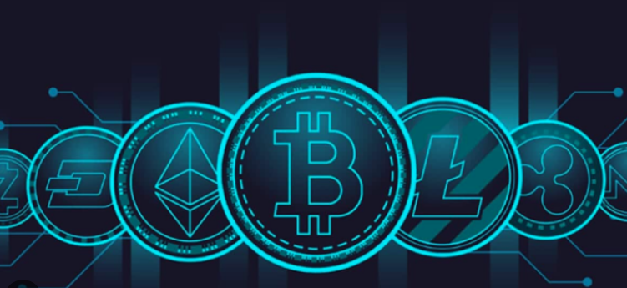

Fig.1

The technology behind cryptocurrencies is primarily based on blockchain technology, although different cryptocurrencies may have variations in their underlying protocols. Here's an overview of the key components:

1. Blockchain: A blockchain is a decentralized and distributed ledger that records all transactions in a transparent and tamper-resistant manner. It consists of a chain of blocks, where each block contains a set of transactions. Each block is linked to the previous one, creating a chronological order of transactions. The blockchain is maintained and updated by a network of computers (nodes) participating in the cryptocurrency's network.
2. Cryptography: Cryptocurrencies rely on cryptographic techniques to secure transactions, control the creation of new units, and verify the integrity of the blockchain. Public-key cryptography is commonly used to generate pairs of public and private keys. The public key serves as the recipient's address, while the private key is used to sign and authorize transactions.
3. Consensus Mechanisms: Consensus mechanisms are protocols that ensure agreement among network participants about the validity of transactions and the order in which they are added to the blockchain. The most well-known consensus mechanism is Proof-of-Work (PoW), where miners compete to solve complex mathematical puzzles to validate transactions and add blocks to the blockchain. Other consensus mechanisms, such as Proof-of-Stake (PoS) and Delegated Proof-of-Stake (DPoS), allocate block validation rights based on the stake or voting power held by participants.
4. Wallets: Cryptocurrency wallets are digital applications that allow users to store, manage, and interact with their cryptocurrencies. Wallets securely store the user's private keys and provide interfaces for initiating transactions, checking balances, and accessing other features. Wallets can be software-based (desktop, mobile, or web wallets), hardware devices (physical wallets), or even paper-based (where keys are printed on paper).
5. Mining: Mining is the process by which new units of cryptocurrency are created and transactions are validated. Miners use computational power to solve complex mathematical problems, and the first miner to find a valid solution is rewarded with newly minted cryptocurrency. Mining also plays a critical role in maintaining the security and integrity of the blockchain.
6. Smart Contracts (optional): Some cryptocurrencies, such as Ethereum, incorporate smart contract functionality. Smart contracts are self-executing contracts with the terms of the agreement directly written into code. They enable automated and trustless execution of agreements, providing programmable functionalities and facilitating various applications, such as decentralized applications (DApps) and decentralized finance (DeFi).

It's important to note that the technology behind cryptocurrencies is evolving rapidly, and different cryptocurrencies may implement different variations or enhancements to the underlying technology.

**Solana currency**

The Solana is a high-performance blockchain designed to facilitate fast and cheap transactions while maintaining high security and decentralization. Here's a brief overview of how Solana works:

Consensus mechanism: Solana uses a proof-of-stake consensus mechanism called Proof of History (PoH) combined with Proof of Stake (PoS). PoH is a verifiable delay function that creates a time-stamping mechanism for transactions, enabling the validators to agree on the order of transactions without communicating with each other. This allows Solana to process transactions in parallel, reducing confirmation times and increasing throughput.

Transaction processing: Once a transaction is submitted to the Solana network, it is validated by a set of nodes called "replicas." These replicas use the PoH time-stamping mechanism to validate the transaction and add it to a block. Each block in Solana can contain up to 65,536 transactions, and multiple blocks can be processed in parallel.

Sharding: Solana also uses a technique called "sharding" to improve scalability. Sharding involves splitting the network into smaller sub-networks called "shards," with each shard processing transactions independently. This allows Solana to scale horizontally, increasing its capacity as more validators join the network.

Smart contracts: Solana supports smart contracts using the Solana Program Library (SPL), a collection of pre-built programs that can be used to create decentralized applications (dApps) on the Solana blockchain. Developers can also write custom smart contracts using the Rust programming language.

Tokenomics: Solana has its native cryptocurrency called SOL, which is used to pay for transaction fees and participate in network governance. The total supply of SOL is capped at 500 million, with a circulating supply of approximately 273 million at the time of writing.

**1.4 MOTIVATION TO IMPLEMENT:**

The motivation behind creating a crypto token varies depending on the individual or organization involved. Some reasons could include raising funds for a project or venture, creating a new form of digital currency, providing a means for users to access a specific platform or service, or incentivizing certain behaviors within a community. Overall, the appeal of crypto tokens lies in their decentralized nature and potential for democratizing financial systems.

* Crypto tokens can provide a way to offer rewards or incentives to users for participating in a particular ecosystem or network.
* For startups and entrepreneurs, creating a crypto token can be a way to raise funds without having to go through traditional venture capital or investment routes.
* In some cases, crypto tokens may be created as a means of circumventing government regulations or restrictions on traditional financial systems.
* Crypto tokens can also serve as a way to decentralize ownership and governance of a platform or project, allowing for more community-driven decision-making.
* The potential for growth and value appreciation of crypto tokens is another motivator for their creation, as seen with the success of Bitcoin and other early cryptocurrencies.
* For developers, creating a crypto token can be a way to experiment with new technologies and blockchain-based applications.
* In the case of utility tokens, they may be created to serve a specific function within a platform or ecosystem, such as providing access to premium features or discounts on products and services.

CHAPTER 2

System Analysis

CHAPTER 2

System Analysis

**CHAPTER 2**

**System Analysis**

**EXISTING METHODOLOGY:**

Ethereum is a popular blockchain platform that supports smart contracts and decentralized applications (DApps). Its methodology consists of several key components:

1. Ethereum Virtual Machine (EVM): Ethereum incorporates a virtual machine called the Ethereum Virtual Machine. It enables the execution of smart contracts by running bytecode instructions.
2. Proof of Work (PoW) and Consensus: Historically, Ethereum has used a Proof of Work consensus mechanism similar to Bitcoin. Miners compete to solve complex mathematical puzzles to validate transactions and create new blocks. However, Ethereum is transitioning to a Proof of Stake (PoS) consensus mechanism called Ethereum 2.0. PoS relies on validators who hold and lock up their Ether (ETH) as collateral to secure the network and validate transactions.
3. Gas and Transaction Fees: Ethereum uses a concept called "gas" to measure the computational effort required to execute transactions and smart contracts. Each operation in the EVM consumes a specific amount of gas, and users must pay gas fees to compensate for the computation performed. Gas fees are paid using Ether and serve as an incentive for miners/validators to include transactions in blocks.
4. Solidity Programming Language: Ethereum introduced Solidity, a high-level programming language specifically designed for writing smart contracts on the Ethereum platform. Solidity enables developers to define the logic and behavior of smart contracts and deploy them on the Ethereum blockchain.
5. Decentralized Applications (DApps): Ethereum provides a platform for building decentralized applications. Developers can leverage Ethereum's infrastructure, smart contracts, and token standards (like ERC-20 and ERC-721) to create various DApps, including decentralized finance (DeFi) protocols, non-fungible token (NFT) marketplaces, and more.

**Proof-of-Work (PoW)**

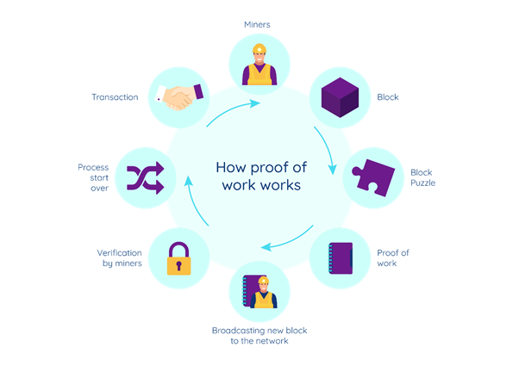

Fig.2

Proof of Work (PoW) is a consensus mechanism used in blockchain networks, including many cryptocurrencies like Bitcoin. It serves as a way to validate and secure transactions while preventing malicious actors from manipulating the blockchain. Here's how Proof of Work works:

1. Transaction Validation: When a user initiates a transaction in a blockchain network, it is broadcasted to all participating nodes in the network.
2. Mining Nodes: Miners are specialized nodes in the network that compete to validate and add transactions to the blockchain. Miners collect pending transactions and include them in a block.
3. Hashing and Nonce: Miners must find a "nonce" (a random number) that, when combined with other transaction data, generates a hash value that meets certain criteria. The hash value is a fixed-length alphanumeric string that uniquely represents the block's data.
4. Difficulty Target: The network adjusts the difficulty target to regulate the rate of block creation. The difficulty target determines how many leading zeros the resulting hash value must have to be considered valid. A lower target makes the puzzle more difficult to solve.
5. Trial-and-Error: Miners employ a trial-and-error process, repeatedly changing the nonce and rehashing the block data until a hash value is found that meets the difficulty target. The process requires significant computational power and energy consumption.
6. Validating the Solution: Once a miner finds a valid hash value that meets the difficulty target, they announce it to the network along with the nonce and other relevant data. Other nodes can easily verify the solution by rehashing the block data using the announced nonce. If the hash value matches the difficulty target, the solution is considered valid.
7. Block Addition and Reward: The miner who successfully finds the valid solution adds the block to the blockchain, linking it to the previous block. As a reward for their efforts, the miner receives a predetermined amount of cryptocurrency. This process of adding new blocks to the blockchain is often referred to as "mining."
8. Longest Chain Rule: In the case of competing valid solutions discovered simultaneously by different miners, a temporary fork may occur, resulting in multiple potential versions of the blockchain. The network automatically resolves this by following the "longest chain rule," where miners continue building on the longest chain, considering it as the true version of the blockchain.

Proof of Work's security lies in the fact that it is computationally expensive to find valid solutions. This means that any malicious entity attempting to alter the blockchain's history would need to control a majority of the network's computational power, known as a 51% attack, which becomes increasingly difficult as the network grows.

**Proof-of-Stake (PoS)**

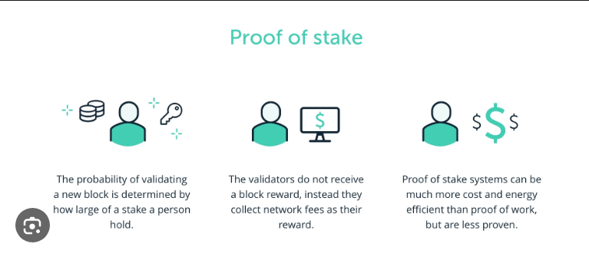

Fig.3

Proof of Stake (PoS) is a consensus mechanism used in blockchain networks as an alternative to Proof of Work (PoW). It aims to validate and secure transactions based on the stake (ownership) of participants in the network. Here's how Proof of Stake works:

* Participant Ownership: In a PoS system, participants (also called validators) must show ownership or stake in the cryptocurrency of the blockchain network. The stake is typically determined by the number of coins held by the participant. Owning more coins increases the chances of being selected to validate transactions.
* Block Creation and Validation: In a PoS network, instead of miners competing to solve computationally intensive puzzles, validators are chosen to create new blocks and validate transactions based on their stake. The selection process is usually based on a pseudo-random algorithm that considers the size of the stake.
* Block Selection: The algorithm selects validators to create a new block based on factors like the number of coins they hold and the duration of their stake. The likelihood of being chosen as a validator is proportional to the stake held. Validators are usually chosen in a deterministic or pseudorandom manner, reducing the need for excessive computational power.
* Transaction Validation and Block Addition: Once a validator is selected, they create a new block and validate transactions. Validators do not compete against each other but rather take turns creating blocks based on their stake. Validators' chances of being selected for block creation increase with their stake, which aligns their interests with the security and stability of the network.
* Verification by Stakeholders: Validators propose the new block to the network, and other stakeholders (holders of the cryptocurrency) can verify its correctness. This verification process ensures that the proposed block adheres to the protocol rules and does not contain any fraudulent or invalid transactions.
* Consensus and Reward: Consensus is reached when a supermajority of validators agrees on the validity of the block. Validators who successfully validate transactions and propose valid blocks are rewarded with transaction fees or newly minted cryptocurrency, similar to how miners are rewarded in Proof of Work.
* Security and Attacks: PoS systems are designed to deter malicious behavior through economic incentives. In the case of an attack, where a validator tries to manipulate the blockchain, their stake can be partially or fully confiscated as a penalty, disincentivizing fraudulent activity.

Proof of Stake offers potential advantages over Proof of Work, such as reduced energy consumption, as it eliminates the need for computationally intensive mining. It also aims to decentralize power by distributing the validation process among stakeholders based on their stake in the network. However, it does introduce potential concerns related to stake centralization and the "rich get richer" effect, where those with more stake have higher chances of being selected as validators. Various variations of PoS exist, such as Delegated Proof of Stake (DPoS), which introduces a voting system where stakeholders elect delegates to validate transactions on their behalf.

**Proof-of-History (PoH)**

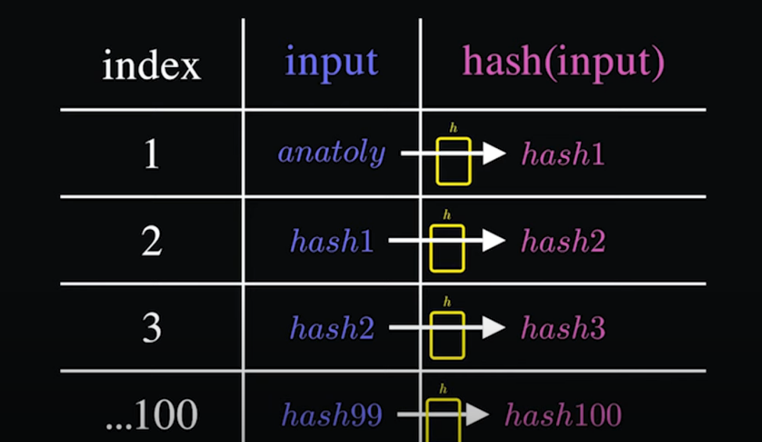

Fig.4

Proof of History (PoH) is a consensus mechanism designed to provide a verifiable and reliable ordering of events in a blockchain network. It aims to solve the issue of timestamping and ordering of transactions or events without requiring computationally intensive calculations or relying solely on the passing of time. PoH was introduced by the Solana blockchain.

Here's an explanation of how Proof of History works:

1. Time Sequencing: PoH uses a decentralized clock to establish a consistent and accurate order of events within the blockchain network. This clock generates a verifiable sequence of timestamps that can be used to order and validate transactions.
2. Verifiable Delay Functions (VDFs): PoH utilizes cryptographic primitives known as Verifiable Delay Functions. These functions take an input and require a certain amount of time to compute an output, which serves as the proof of the elapsed time. Verifying the output is significantly faster than computing it.
3. Generating Historical Proofs: In PoH, a leader node, known as the "clock" or "historian," generates and includes a PoH hash in each block. This PoH hash represents the sequence of timestamps that have been generated over time. Each new block extends the sequence and includes a cryptographic proof of the elapsed time since the previous block.
4. Validation and Ordering: Participants in the network can verify the PoH hash and the historical proofs included in each block to independently validate the order of events. The cryptographic nature of PoH ensures that the timestamps are secure and tamper-proof.
5. Consensus Mechanism Integration: Proof of History can be combined with other consensus mechanisms like Proof of Stake or Proof of Work to establish a comprehensive and secure blockchain network. PoH primarily focuses on the order and timestamping of events, while other consensus mechanisms handle the validation and agreement on the state of the blockchain.

By providing a reliable and verifiable order of events, Proof of History enhances the scalability and efficiency of blockchain networks. It enables faster confirmation times and facilitates the parallel processing of transactions, as participants can independently verify the order without relying on continuous consensus rounds. However, it's important to note that Proof of History is just one component of a complete consensus mechanism and is typically used in conjunction with other mechanisms to create a robust blockchain system.

**2.3 Proposed System and Software**

In our system we will be using Remix IDE for Deployment of our contract

1. **Contract written on Remix IDE**

Remix IDE is a popular integrated development environment (IDE) specifically designed for developing and testing smart contracts on the Ethereum blockchain. It provides a user-friendly interface and a comprehensive set of tools to write, compile, deploy, and debug Ethereum smart contracts.

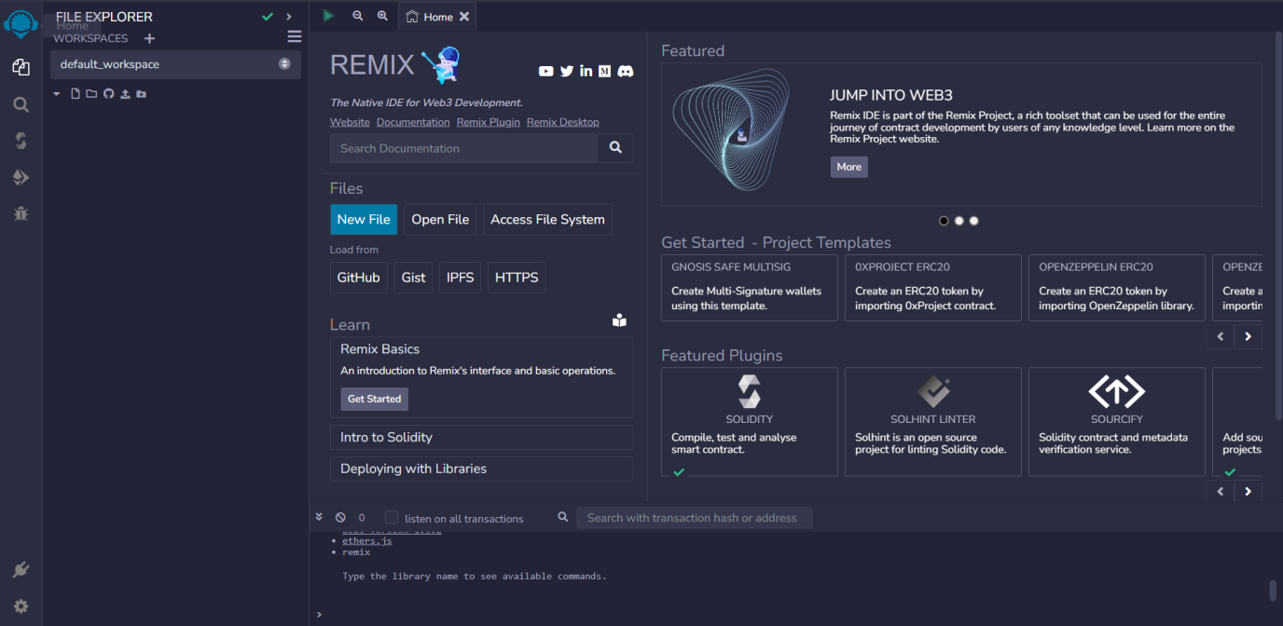

Fig.5

1. **Meta-Mask Wallet**

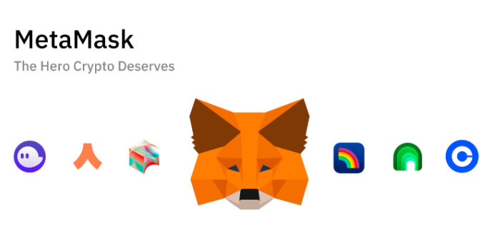

Fig.6

MetaMask is a popular browser extension and mobile application that serves as a digital wallet and gateway to the Ethereum blockchain. It enables users to interact with decentralized applications (DApps) and manage their Ethereum-based cryptocurrencies and assets. Here's a detailed explanation of MetaMask:

1. Digital Wallet: MetaMask acts as a secure digital wallet that allows users to store, manage, and interact with their Ethereum-based cryptocurrencies. It provides users with a unique Ethereum address, which they can use to receive funds from others.
2. Browser Extension and Mobile App: MetaMask is available as a browser extension for popular browsers like Google Chrome, Firefox, and Brave. It can also be downloaded as a mobile app for iOS and Android devices, allowing users to access their Ethereum wallet and DApps on the go.
3. Ethereum Network Access: MetaMask connects users to the Ethereum blockchain, enabling them to interact with smart contracts and decentralized applications. It serves as a bridge between the user's web browser or mobile device and the Ethereum network.
4. DApp Integration: MetaMask allows users to seamlessly interact with various Ethereum-based DApps. When users visit a DApp-enabled website, MetaMask automatically detects the integration and provides a user interface to interact with the DApp, such as authorizing transactions or accessing user-specific features.
5. Transaction Management: With MetaMask, users can initiate and authorize transactions on the Ethereum network. When users want to send funds or interact with a smart contract, MetaMask prompts them to review and confirm the transaction details, including the recipient address, amount, and gas fee.
6. Security and Private Keys: MetaMask stores users' private keys encrypted in their local browser or device. Users have full control over their private keys, which are necessary to access and manage their Ethereum assets. It's crucial to back up and secure the private keys properly to prevent unauthorized access to the wallet.
7. Network Customization: MetaMask allows users to connect to different Ethereum networks, such as the Ethereum Mainnet, Testnets (Ropsten, Rinkeby, Kovan), and custom private networks. This flexibility enables developers and users to test and deploy applications on various network environments.
8. Token Management: MetaMask supports the management of various Ethereum-based tokens, including popular standards like ERC-20 and ERC-721. Users can view their token balances, send tokens, and interact with token-specific functionalities within the MetaMask interface.
9. Browser Integration: MetaMask seamlessly integrates with web browsers, providing a user-friendly interface and convenient access to Ethereum-based services and DApps. Users can interact with Ethereum-enabled websites without the need for separate wallets or manual transaction management.

It's important to note that while MetaMask provides a user-friendly experience, it's essential to exercise caution and adhere to security best practices to protect your digital assets. This includes keeping your software up to date, avoiding phishing attempts, and securely storing your private keys or recovery phrases.

**3.Pancake Swap Exchange**



Fig.7

This Exchange is used to provide Liquidity to our token

PancakeSwap is a decentralized exchange (DEX) built on the Binance Smart Chain (BSC), which allows users to trade cryptocurrencies directly with one another without the need for intermediaries. It operates similarly to other decentralized exchanges but with some unique features. Here's an explanation of how PancakeSwap works:

Liquidity Pools: PancakeSwap operates on an automated market maker (AMM) model. Instead of relying on order books, liquidity is provided by users who deposit their cryptocurrency into liquidity pools. Each pool contains a pair of tokens, such as BNB (Binance Coin) and BUSD (Binance USD), and users can contribute to the liquidity of those pools.

Liquidity Providers: Users who contribute to liquidity pools become liquidity providers (LPs). By depositing an equal value of both tokens in a pool, LPs receive liquidity provider tokens (LP tokens) in return. These LP tokens represent their share of the pool and allow them to withdraw their portion of the liquidity at any time.

Swapping Tokens: Users can swap one cryptocurrency for another directly on PancakeSwap. They select the token they want to trade and the token they want to receive, and PancakeSwap automatically calculates the exchange rate based on the available liquidity in the respective pools. The swapping process is executed instantly and without the need for a centralized authority.

Automated Market Maker (AMM) Algorithm: PancakeSwap utilizes an AMM algorithm called the Constant Product Market Maker (CPMM) formula. This formula ensures that the product of the reserve balances in a liquidity pool remains constant before and after a trade, which determines the exchange rate. As a result, larger trades will have a greater impact on the price due to slippage.

Yield Farming and Staking: PancakeSwap provides opportunities for users to earn additional rewards through yield farming and staking. Users can stake their LP tokens or specific tokens on the platform to earn CAKE, the native token of PancakeSwap. Additionally, users can participate in various farming pools to earn additional tokens by providing liquidity to those pools.

Syrup Pools: Syrup Pools are special farming pools on PancakeSwap that allow users to stake their CAKE tokens and earn other tokens as rewards. These pools provide incentives for users to hold and participate in the PancakeSwap ecosystem.

Lottery and Initial Farm Offerings (IFOs): PancakeSwap occasionally offers lotteries and IFOs to provide opportunities for users to participate and potentially win tokens or purchase tokens at a predetermined price. These events often create excitement and engagement within the community.

It's important to note that as a decentralized exchange, PancakeSwap operates on the Binance Smart Chain, which may have different characteristics and considerations compared to other blockchains like Ethereum. Users should be mindful of gas fees, transaction speed, and security considerations when using PancakeSwap or any other decentralized exchange

**2.3 Hardware and Software Specifications**

* Basic System to write a contract with Internet connection.
* Metamask installed web extension or downloaded application.
* Hardware wallet
* PooCoin Exchange



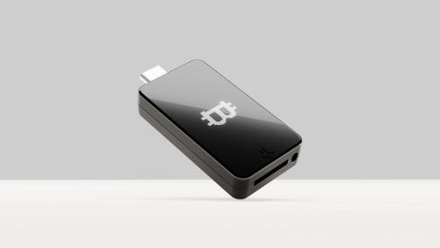 



CHAPTER 3

System Design

**CHAPTER 3**

**System Design**

* 1. **Architecture of blockchain**

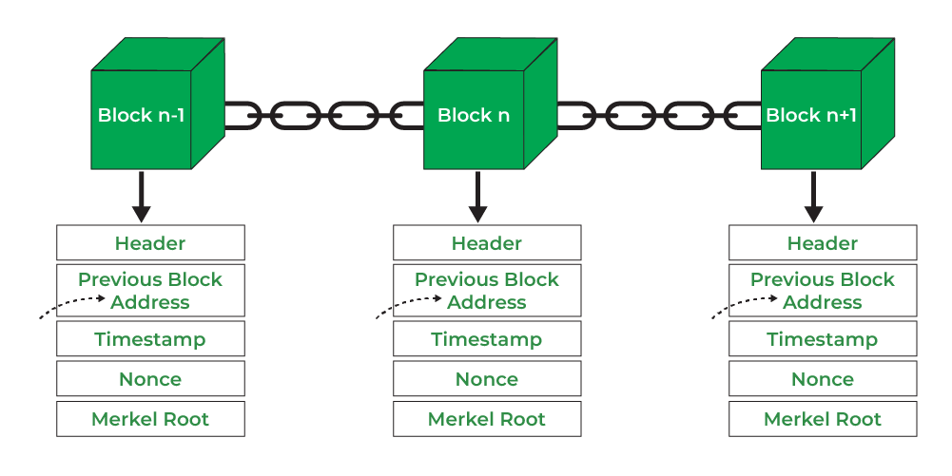

* 1. **Working of Blockchain**

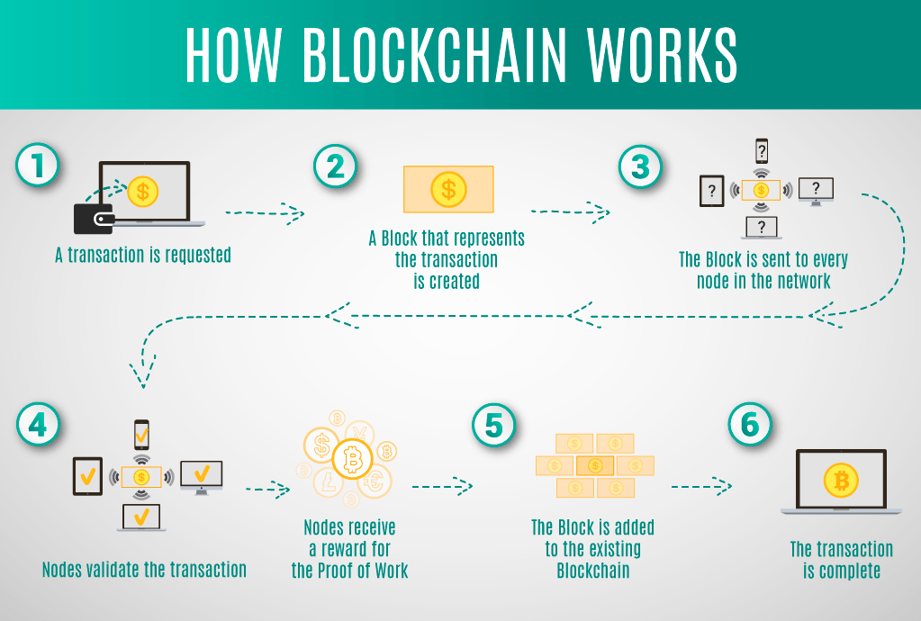

Fig.7

**1**.**Contract written on Remix IDE**

Remix IDE is a popular integrated development environment (IDE) specifically designed for developing and testing smart contracts on the Ethereum blockchain. It provides a user-friendly interface and a comprehensive set of tools to write, compile, deploy, and debug Ethereum smart contracts.

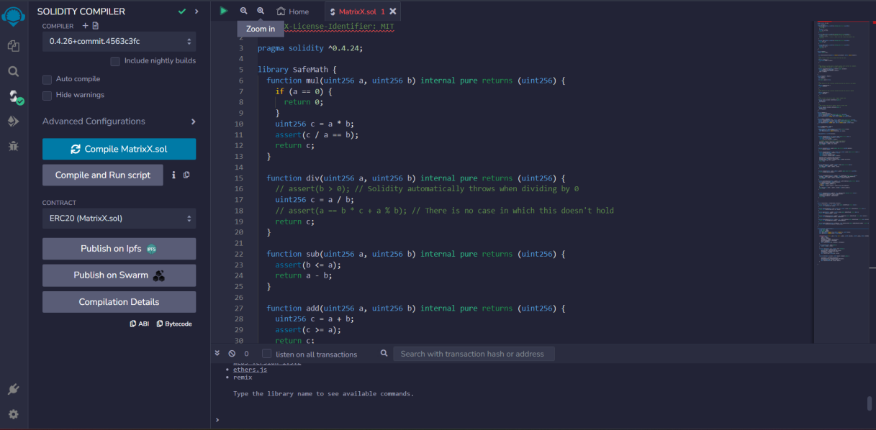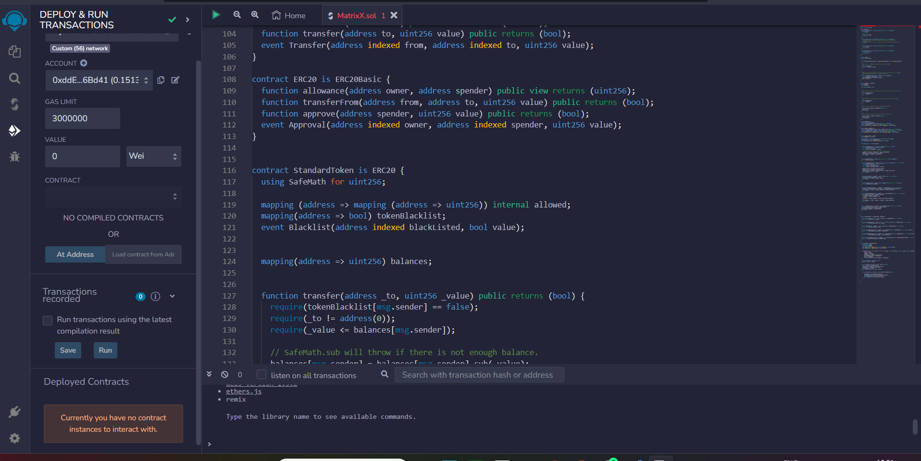

Fig.8

1. **Test token from Sepolia Faucet. (for testing)**

Alchemy is a blockchain infrastructure platform that provides developers with a suite of tools and services to build and scale applications on various blockchain networks, primarily focusing on Ethereum. It offers a range of features designed to simplify and enhance the development process, improve scalability, and provide reliable access to blockchain data.

Here we get a test ETH to deploy the contract on Ethereum Blockchain

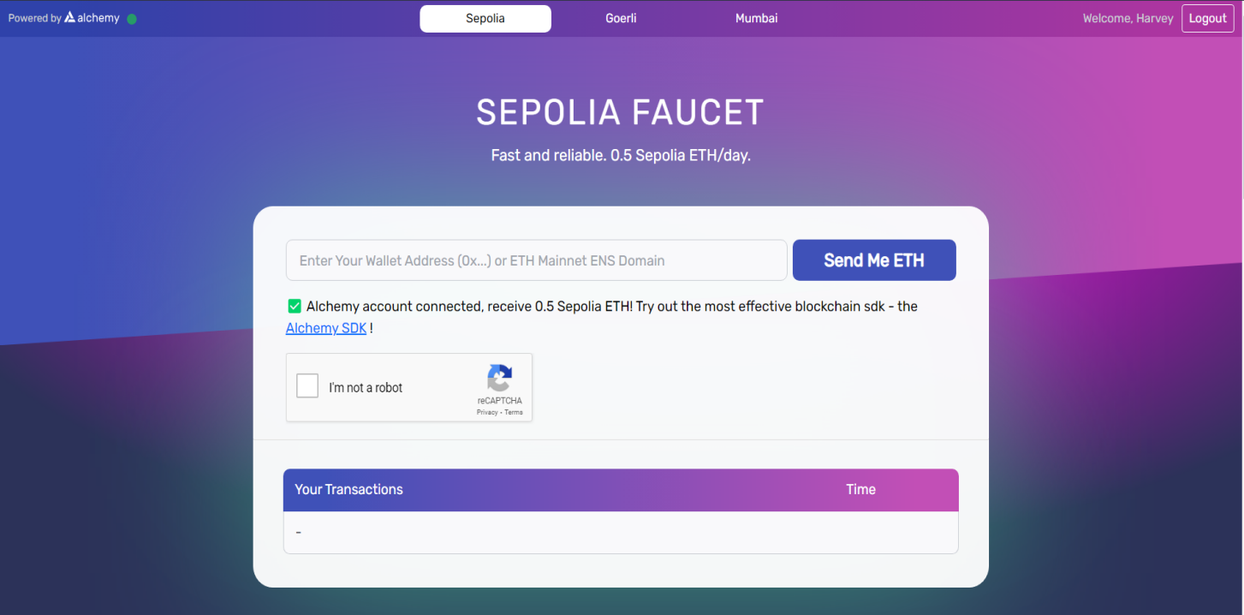

Fig.9

1. **Integration of Interface and Metamask**

During this Integration we connect our contract with meta mask to transact test ETH so we can deploy our contract.

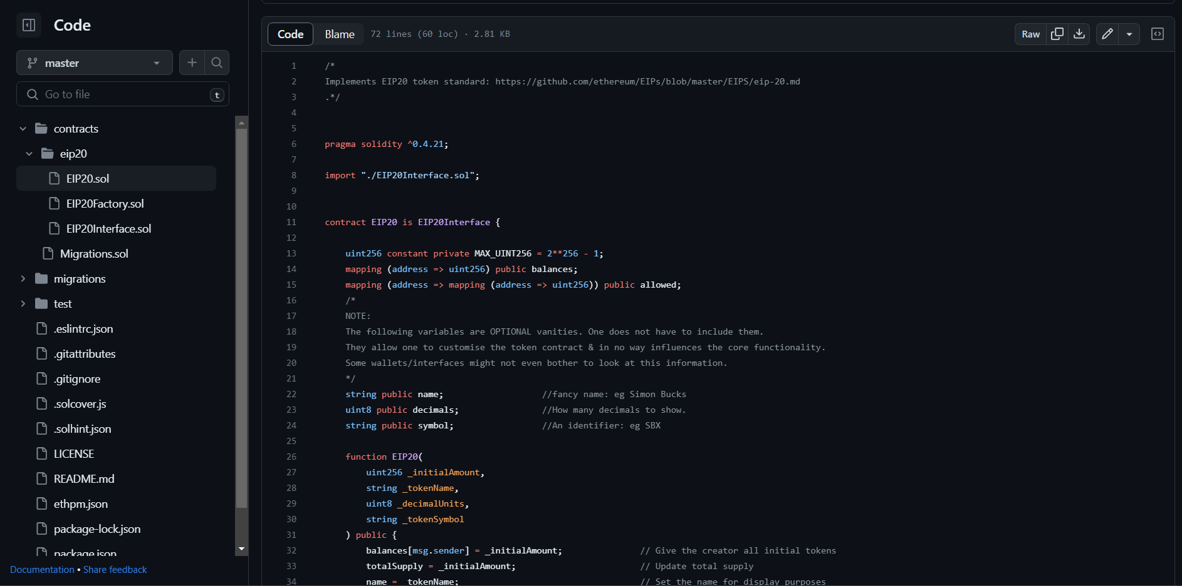



Fig.10

1. **Deployment of Contract constrain.**

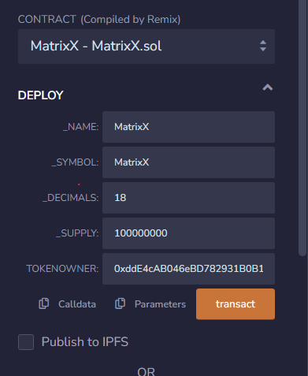

Fig.11

Here we will the token name , symbol, decimals , total supply of the token that need to be deployed and give in the address of the contract owner and click on the transact to connect the Metamask and our IDE.

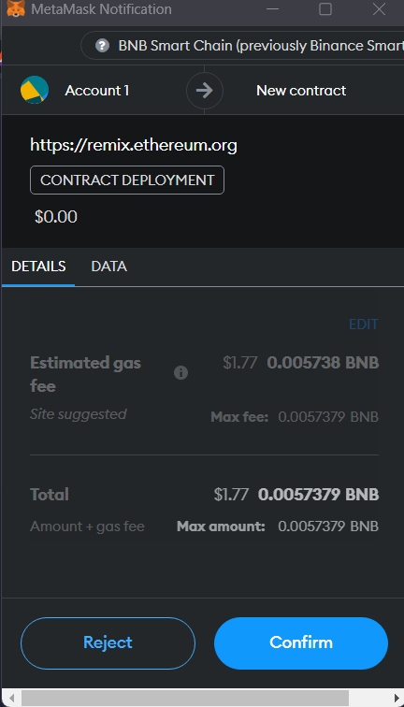



Fig.12

Block of our contract gets created and we get the details of our contract.

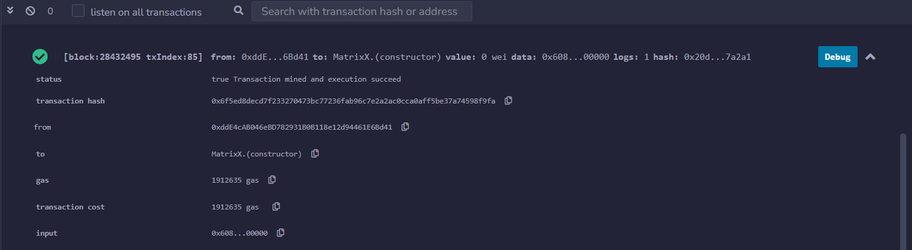

Fig.13

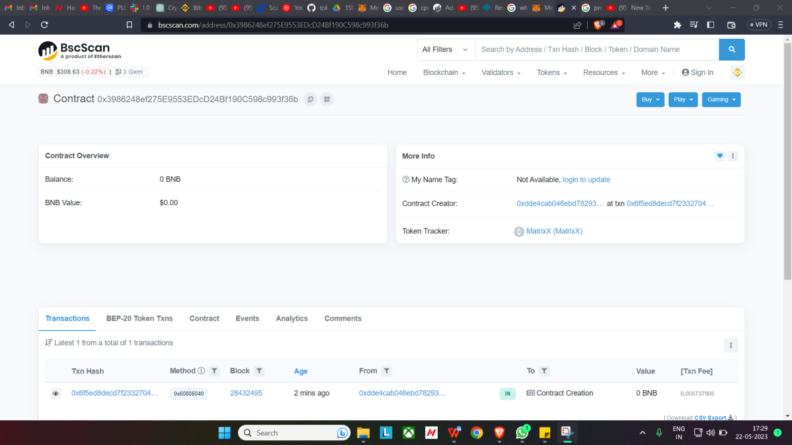

Fig.14

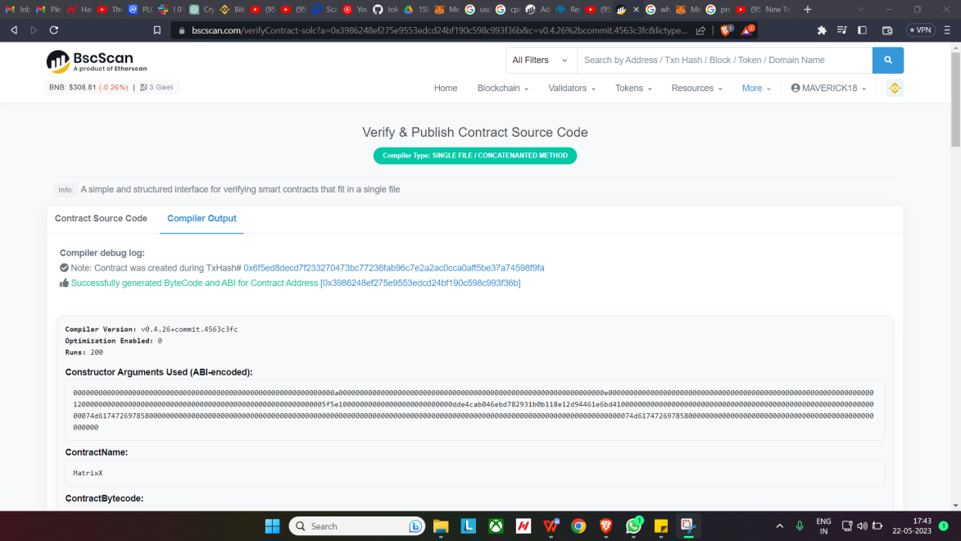

Fig.15

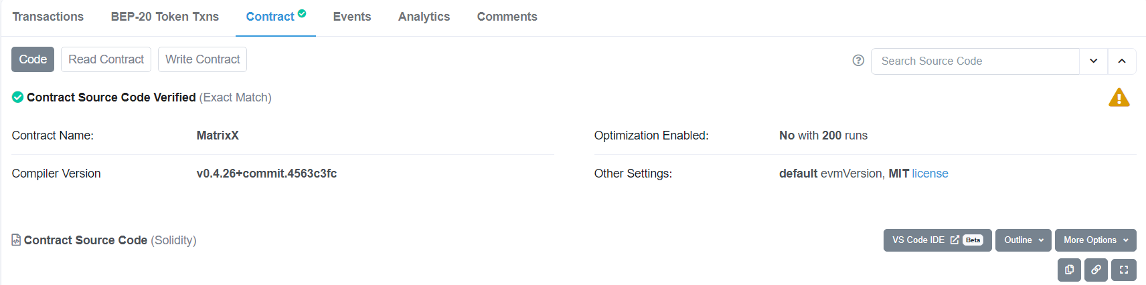

Fig.16

In above figure after the contrat is deployed on BSC Chain (Binance Smart Contract) we need to verify and publish on the chain to do that we need click on verify and publish as shown in Fig.15 .Once the ontract is succesfully deployed on the BSC Chain as shown in Fig.16 we can import the tokens to owner address.

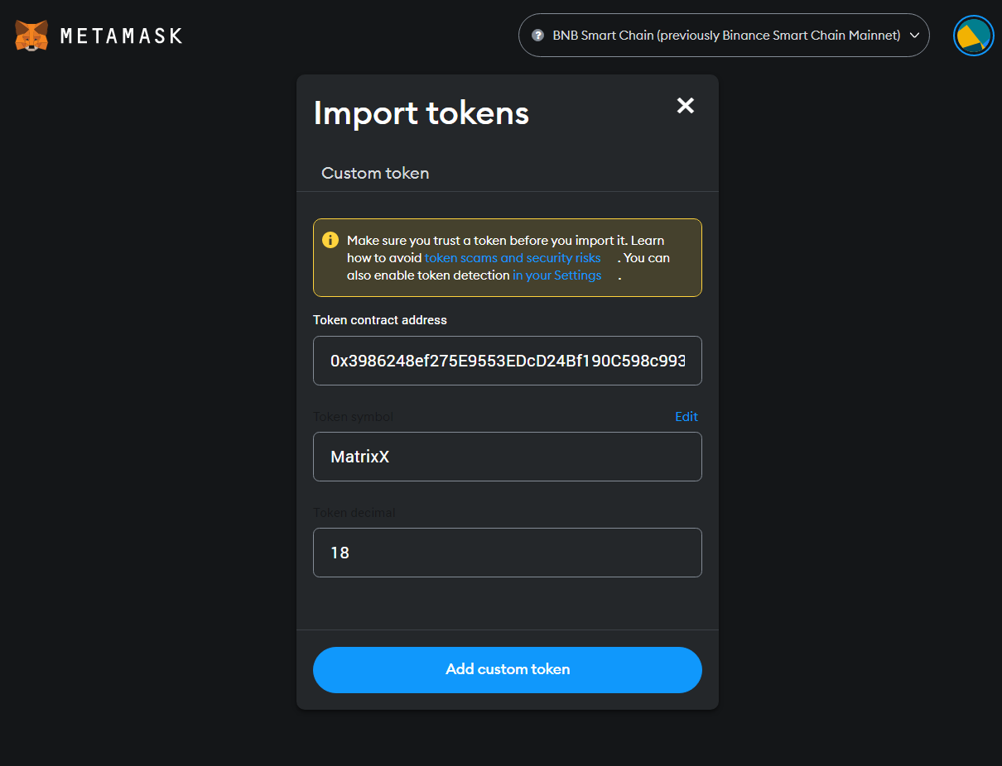

Fig.17

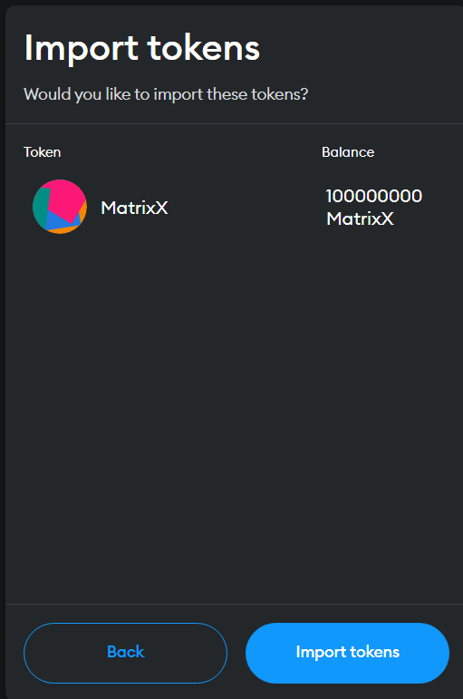

Fig.18

After Import our token to the Owner Address as shown in above Fig.17 and Fig.18 and move on the the liquidty pool to provide the liquidity to our token on pancake exchange and one the liquidity is been given we can check the market cap on Poocoin .

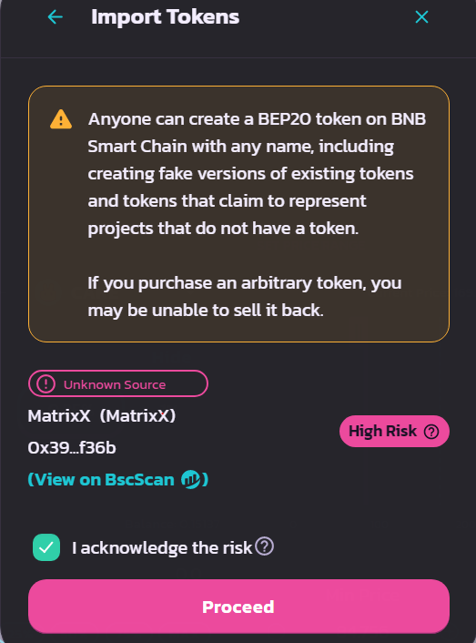

CHAPTER 4

Conclusion

**CHAPTER 4**

**Conclusion**

In conclusion, working with a crypto token on the Binance Smart Chain (BSC) offers numerous advantages and opportunities. BSC has emerged as a popular blockchain platform, providing a range of benefits for token issuers and users alike. Here are some key takeaways:

High Speed and Low Fees: BSC boasts fast block times and low transaction fees compared to other networks. This ensures quick and cost-effective token transfers and interactions, enhancing user experience and facilitating efficient transactions.Wide User Adoption: Binance Smart Chain has garnered significant adoption within the crypto community. Its integration with the Binance ecosystem, including the popular Binance exchange, has attracted a large user base, increasing the visibility and potential liquidity for tokens built on the BSC.

Interoperability: BSC's compatibility with the Ethereum Virtual Machine (EVM) enables seamless migration of tokens and smart contracts from the Ethereum network to BSC. This interoperability facilitates a broader reach for token projects and allows for the utilization of existing Ethereum tools and resources.

**References**

1. Dapp unversity is were you will get a proper understanding of the Blockchain system.

[https://www.dappuniversity.com/](https://dl.acm.org/doi/10.1016/j.ins.2012.09.021)

1. Etherum website

[https://ethereum.org/en/](https://dl.acm.org/doi/10.1016/j.ins.2012.09.021)

[3) Networkchuck deployment on contract on solona blockchain](https://dl.acm.org/doi/10.1016/j.ins.2012.09.021)

[https://learn.networkchuck.com/](https://dl.acm.org/doi/10.1016/j.ins.2012.09.021)

4) Open contract code of Contract on Github

<https://github.com/CEO-Token/token/blob/main/token.sol>

1. BSC Scanner

<https://bscscan.com/>

1. Remix.etherum.org IDE

<https://remix.ethereum.org/#lang=en&optimize=false&runs=200&evmVersion=null&version=soljson-v0.4.26+commit.4563c3fc.js&language=Solidity>

1. Pancake exchange

https://pancakeswap.finance/add/BNB/0x3986248ef275E9553EDcD24Bf190C598c993f36b/100?minPrice=0.01&maxPrice=